**Article 375 of IPC or 63 of BNS-** Is about the Definition of RAPE

*IMP: Section 375 of the IPC which dealt with the offence of rape mirrored Section 63 in the BNS which increased the scope of the definition of rape.*

A man is said to commit “rape” if he:

1. penetrates his penis, to any extent, into the vagina, mouth, urethra or anus of a woman or makes her to do so with him or any other person; or
2. inserts, to any extent, any object or a part of the body, not being the penis, into the vagina, the urethra or anus of a woman or makes her to do so with him or any other person; or
3. manipulates any part of the body of a woman so as to cause penetration into the vagina, urethra, anus or any part of body of such woman or makes her to do so with him or any other person; or
4. applies his mouth to the vagina, anus, urethra of a woman or makes her to do so with him or any other person, under the circumstances falling under any of the following seven descriptions:
   1. against her will.
   2. without her consent.
   3. with her consent, when her consent has been obtained by putting her or any person in whom she is interested, in fear of death or of hurt.
   4. with her consent, when the man knows that he is not her husband and that her consent is given because she believes that he is another man to whom she is or believes herself to be lawfully married.
   5. with her consent when, at the time of giving such consent, by reason of mental illness or intoxication or the administration by him personally or through another of any stupefying or unwholesome substance, she is unable to understand the nature and consequences of that to which she gives consent.
   6. with or without her consent, when she is under eighteen years of age.
   7. when she is unable to communicate consent.

**Explanation 1:** For the purposes of this section, “vagina” shall also include labia majora.

**Explanation 2:** Consent means an unequivocal voluntary agreement when the woman by words, gestures or any form of verbal or non-verbal communication, communicates willingness to participate in the specific sexual act;

**Provided** that a woman who does not physically resist to the act of penetration shall not by the reason only of that fact, be regarded as consenting to the sexual activity.

**Exception 1:** A medical procedure or intervention shall not constitute rape.

**Exception 2:** Sexual intercourse or sexual acts by a man with his own wife, the wife not being under eighteen years of age, is not rape.

**Article 299 of CrPC or 100 of BNS-** is About the Culpable Homicide

*The BNS replaced the Indian Penal Code (IPC) in 2023, but only changed the section numbers of the provisions, not the wording. The new and old section numbers for culpable homicide are:*

*BNS Section 100: Culpable homicide*

*IPC Section 299: Culpable homicide*

Whoever causes death by doing an act with the intention of causing death, or with the intention of causing such bodily injury as is likely to cause death, or with the knowledge that he is likely by such act to cause death, commits the offence of culpable homicide.

**Illustrations:**

1. A lays sticks and turf over a pit, with the intention of thereby causing death, or with the knowledge that death is likely to be thereby caused. Z, believing the ground to be firm, treads on it, falls in and is killed. A has committed the offence of culpable homicide.
2. A knows Z to be behind a bush. B does not know it. A, intending to cause, or knowing it to be likely to cause Z’s death, induces B to fire at the bush. B fires and kills Z. Here B may be guilty of no offence; but A has committed the offence of culpable homicide.
3. A, by shooting at a fowl with intent to kill and steal it, kills B, who is behind a bush; A not knowing that he was there. Here, although A was doing an unlawful act, he was not guilty of culpable homicide, as he did not intend to kill B, or to cause death by doing an act that he knew was likely to cause death.

**Explanation:** A person who causes bodily injury to another who is labouring under a disorder, disease or bodily infirmity, and thereby accelerates the death of that other, shall be deemed to have caused his death.

**Article 300 of CrPC or 101 of BNS-** is About the Homicide (Murder)

Except in the cases hereinafter excepted, culpable homicide is murder,

1. if the act by which the death is caused is done with the intention of causing death; or
2. if the act by which the death is caused is done with the intention of causing such bodily injury as the offender knows to be likely to cause the death of the person to whom the harm is caused; or
3. if the act by which the death is caused is done with the intention of causing bodily injury to any person and the bodily injury intended to be inflicted is sufficient in the ordinary course of nature to cause death; or
4. if the person committing the act by which the death is caused, knows that it is so imminently dangerous that it must, in all probability, cause death, or such bodily injury as is likely to cause death, and commits such act without any excuse for incurring the risk of causing death or such injury as aforesaid.

**Difference between homicide and culpable homicide**

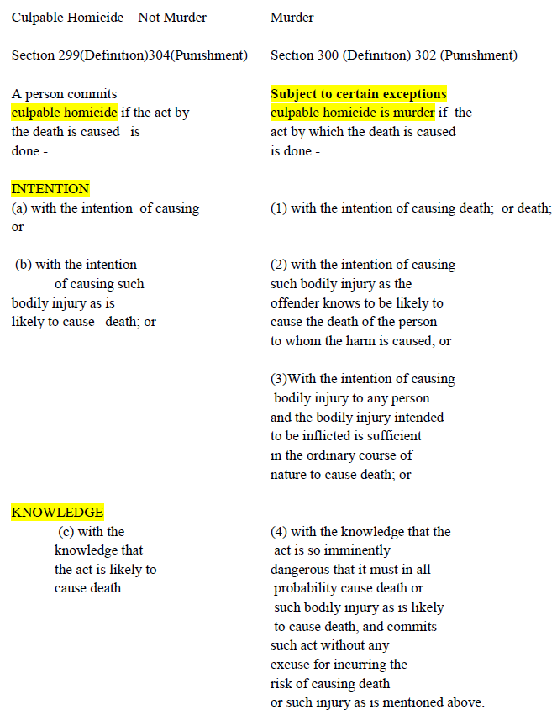

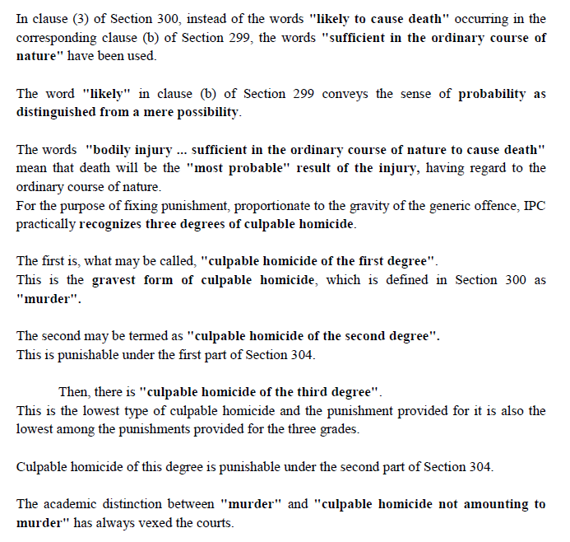

**Section 45 and 46 of IEA –** Is about the Expert Opinion

**Section 45 About the Expert opinions**

When the court has to form an opinion upon a point of foreign law, or of science, or art, or as to identity of handwriting, or finger impressions, the opinions upon that point of persons specially skilled in such foreign law, science or art or in questions as to identity of handwriting or finger impressions, are relevant facts.

Such persons are called experts."

There are three illustrations set out below Section 45. One deals with an opinion as to 'poisoning', the other as to 'unsoundness of mind' and third as to 'identity of handwriting'.

In the 69th Report, after an elaborate discussion, the Commission recommended (end of para 17.44) to include 'footprints, palm impressions or typewriting, as the case may be' in Section 45 and further recommended insertion of Section 45A in regard to the duty of an expert witness to supply copy of his report to all parties, along with the grounds for opinion.

It may be noted that in State (through CBI v. S.J. Choudhary AIR 1996 SC 1491, while holding that experts could be examined with regard to 'typewriting', the 69th Report of the Law Commission was quoted.

Section 45B was proposed to cover expert opinion on 'foreign law' as in the British statutes of 1859, 1861 with two subsections.

**Section 46 in The Indian Evidence Act, 1872**

Facts, not otherwise relevant, are relevant if they support or are inconsistent with the opinions of experts, when such opinions are relevant.

The question is, whether A was poisoned by a certain poison. The fact that other, persons, who were poisoned by that poison, exhibited certain symptoms which experts affirm or deny to be the symptoms of that poison, is relevant.

